# **JoyLine – A Positive Event Timeline**

## **🧠 Concept**

JoyLine is a social web app where users share their important life events (graduations, birthdays, anniversaries, new jobs, etc.).  
 Each event becomes a place full of positivity and shared joy. Users can look back on their timeline to relive happy moments.

## **🧩 User Stories**

* As a user, I can register and log in.
* As a user, I can create, edit, and delete my life events.
* As a user, I can see all users’ events in one shared timeline (sorted by date).
* As a user, I can open an event and add a comment (no anonymity).
* As a user, I can view all the comments left on my events.
* As an admin, I can remove inappropriate comments or manage users.

## **⚙️ Core Features**

* ✅ User authentication (register, login, logout)
* ✅ CRUD for Events (create, read, update, delete)
* ✅ CRUD for Comments (on any event)
* ✅ Timeline feed of all events (sorted by date)
* ✅ Event detail page showing all comments
* ✅ Responsive HTML/CSS styling

## **🏗️ Database / ERD**

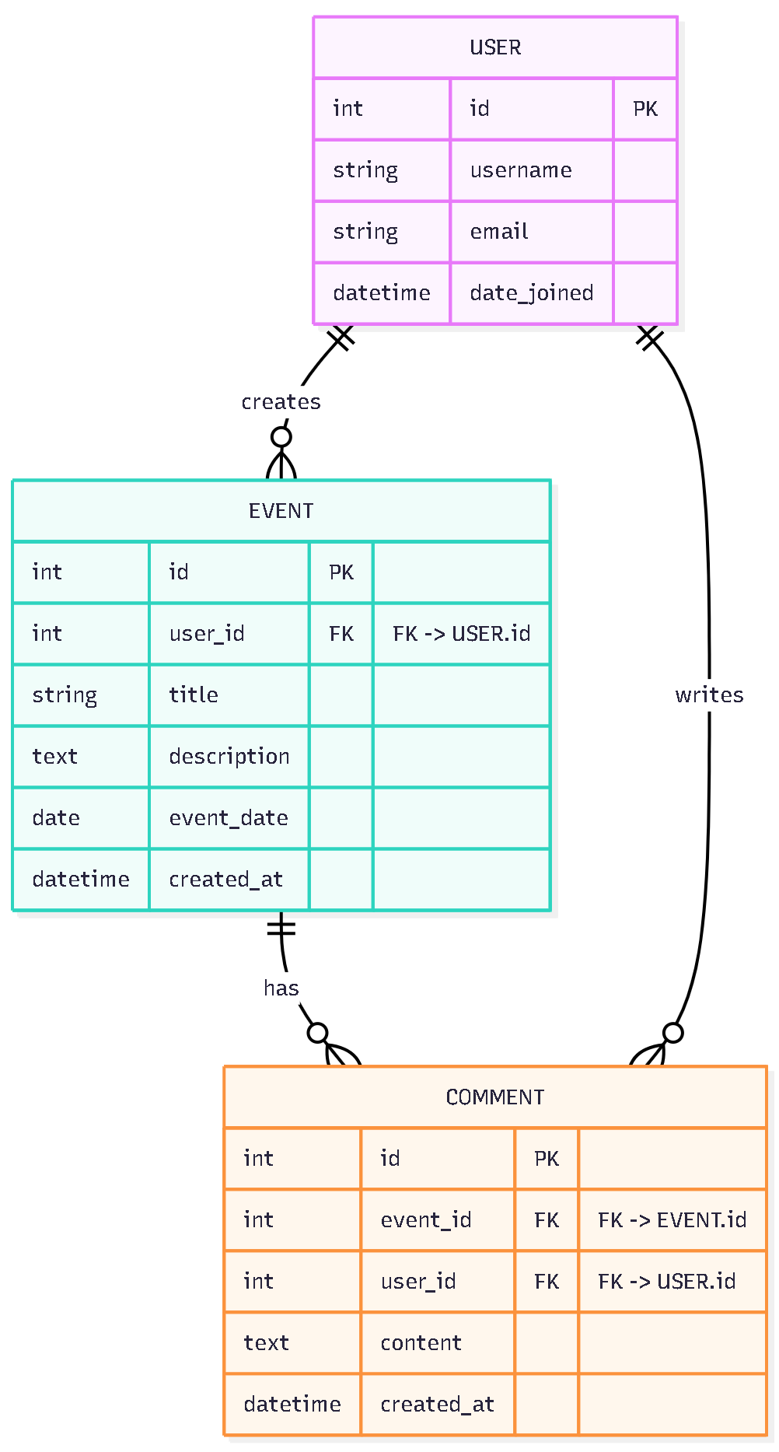

**Relationships:**

* Each user can create many events.
* Each event can have many comments.
* Each comment belongs to one user and one event.

## **🧾 Pages Overview**

|  |  |
| --- | --- |
| **Page** | **Description** |
| Home (Timeline) | Shows all events from all users, sorted by date |
| Event Detail | Shows the event info + all comments + add comment form |
| Add Event | Form for creating a new event |
| Edit Event | Form to update your own event |
| My Events | List of your own events |
| Login / Register | User authentication |

## **🌟 Stretch Goals (Optional)**

* Writing and running unit tests (with or without TDD)
* Adding image or file uploads for events
* Implementing advanced queries, filters, or pagination
* Customizing user profiles (profile picture, bio, etc.)
* Email notifications when someone comments on your event
* Pagination or infinite scroll on the timeline feed

## **🔗 Document All External Resources Used**

* Django Documentation: <https://docs.djangoproject.com/>
* Stack Overflow (for troubleshooting login/logout and form issues)
* W3Schools HTML/CSS guides
* MDN Web Docs (for form validation, CSS styling, and JS references)

## **🛠️ Issues and Project Workflow**

* Issues must remain **active** until resolved.
* Close issues immediately once resolved, and document the solution in the thread.
* Issues without activity for more than 30 minutes will be closed by instructors.
* Closed issues **cannot** be reopened; create a new issue if needed (include link to prior issue).

## **📅 Project Plan**

1. **Authentication Module** – Implement login, logout, signup (reuse current system)
2. **Events CRUD** – Add, edit, delete events
3. **Comments CRUD** – Add comments to events
4. **Timeline View** – Show all events sorted by date
5. **Event Detail** – Show event info + all comments + comment form
6. **User “My Events” Page** – Display all events of the logged-in user
7. **Optional Stretch Features** – Image uploads, filters, reactions, email notifications